**Some design notes for the New Haven Debt Map Project**

--------------------------------------------------------------------------------------------------------------------------

**Conceptual notes**

* Although this is the New Haven Debt Map Project and we should try to have a few maps in the final project, we should generally only have maps when the trends are explicitly geographic. If they are more erratic or there doesn’t seem to be a trend at all, maps can distract and take away from the message at hand

**Concrete notes**

* **Typography**
  + Let’s use Lato (this font) for figures
  + Use a large, bolded font in sentence case for title text. This is probably the most important and sensible advice we could give
  + Follow the 2:1 rule of thumb when choosing font sizes: as we go from title text to paragraph/plot text, choose a size that is half as small as the largest size
    - That might seem like a lot, but with font sizes exaggeration is what we want a lot of the time
* **Maps**
  + Let’s use the [Stamen Toner Background tiles](http://maps.stamen.com/toner-background/#12/41.3087/-72.9253) as a backdrop for our maps, if we get to that stage of styling. For our rough drafts, let’s not worry about it.
  + Use cwi::new_haven_sf for a go-to shapefile in R
* **Colors**

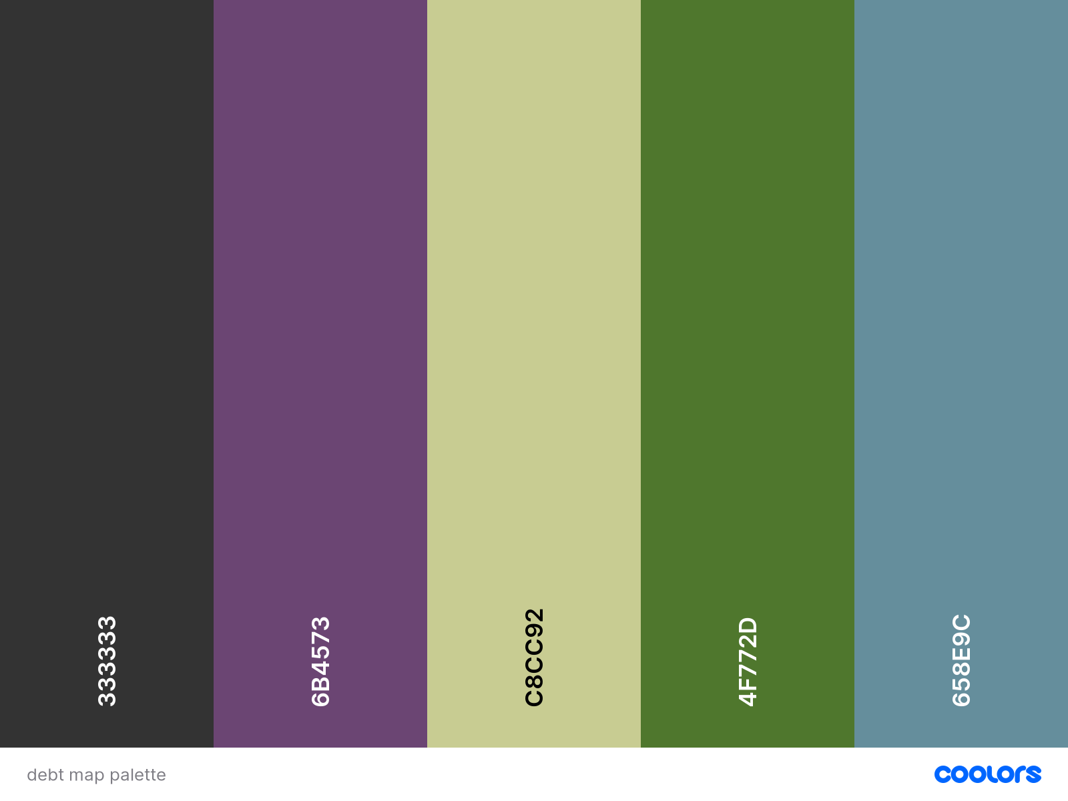

* + Let’s use this color palette for now. Colors are the area I feel the weakest in; I had no idea what to think of for this except to not choose both red and green at once (colorblindness) and to choose muted, dark colors to match the theme of “debt.” If you have additional thoughts or colors you like better, we can go with those :D
* **Misc.** 
  + Slap the DataHaven logo on a chart if you think it’s public-facing/social-media-friendly. You can find two versions below (looks like we’re not great about keeping these together)
    - <https://github.com/CT-Data-Haven/nhv_housing/blob/master/_utils/logo.jpg>
    - <https://github.com/CT-Data-Haven/covidpub/blob/master/img/25th_logo_alpha.png>
  + The tigris, tidycensus, ggplot2, and sf packages are your friends. The Census data website (or any other Census data portal), base R plotting functions, and libraries that don’t seem to be popular are your enemies.